HARIS A
CAREER OBJECTIVE
I would like to be placed in a good position in a reputed firm and enhance my management and personal skills efficiently toward achieving the organizational goal.
HARIS A  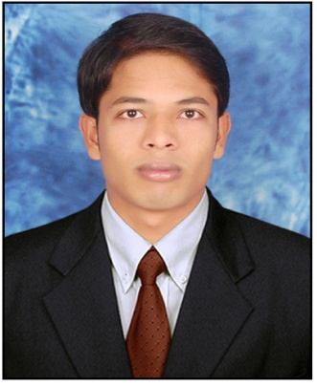  PERSONAL DATA  Father’s Name : IBRAHIM A  Mother’s name :KADEEJA  Date of Birth : 01, 04,1990  Gender : Male  Nationality : Indian  Marital Status : Single  Religion : Muslim  Passport no : J9653314  Identity card no: AVI0069476  Blood Group : B+VE  PERMANENT ADDRESS  Attassery House  Kambalakkad P.O,  Kalpetta(via),Wayanad  Kerala, India, Pin-673122  EMAIL ID  Harisatta9249@gmail.com  CONTACT NO:  Mob: +91 9656498877 | EDUCATION PROFILE  Course : MBA Finance and marketing(2012-2014)  Institution :RR institute of advanced studies  Bangalore, Karnataka  University : Bangalore University  Status : First class  Course : B com (2009-2012)  Institution : WMO Arts and science college  University : Calicut University  Status : First class  Course : Grade12 commerce (2007-2009)  Institution : GHS Kaniyametta  Board : State Board of Higher Secondary  Educations, Kerala.  Status :First class  Course : 10th (2007)  Institution : Govt.Higher secondary school,  Kaniyametta. Kerala  Board : State Board of General Education,  Kerala.  Status :First class  LANGUAGES KNOWN  English, Malayalam and Tamil  COMPUTER PROFICIENCY  Tally 7.2 MS Office  EXPERIENCE  *Financial Controller Enteraxis Network Pvt Ltd,  *HEAD OF THE DEPARTMENTOF BBA WMO IGAS COLLEGE Salary 1,44,000 pa  *Superintendent of WMO Arts and science college  PROJECT:  MINOR PROJECT:  A study on an organizational study at Priyadarshini tea estate m.t.p.c Ltd, mananthavady  MAJOR PROJECT: A study on Fundamental analysis on four banking institutions with special reference to India infoline Ltd.

INDUSTRIES VISITED
- UNIBIC Biscuits India Pvt Ltd Bangalore
- Toyota motor corporation Bangalore
- Turbo Energy Ltd ,Chennai

SEMINARS
- Participated in one day seminar on “ORGANIC ENTERPRENURSHIP AND GEN-Y AWAKENING INDIA”
- Participated in one day seminar on “HYPOTHESIS TESTING AND REPORT WRITTING”
- International seminar on LEADERSHIP
EXTRA CURRICULAR ACTIVITIES.
- Participated in Calicut university bzone arts festival.
- Participated in wayanad revenue school kalotsavam.
- Member of NCC Ranked in “CDT” Category
SKILL SET
  - Hard working A Team player
  - Team spirit Problem solving ability
  - Excellent time management and Patience Sincerity
  - Good Motivator Good in decision making
HOBBIES
- Cricket, Football, Watching News, Reading

DECLARATION
I hereby certify that all the above mentioned facts are true to my knowledge. More reference shall be provided on request.

HARIS A

